Toolbox Talk Record
Project:
Job No.:
Date:
Time:
Duration:
HammerTech is coming to our project.
Engage:
- Ask if your group has experienced issues relating to the topics in the past.
- Share a story related to the topics.

Topic Discussed
BMD projects are migrating to its new HSEQ digital platform, HammerTech.
HammerTech will provide a more consistent experience for BMD subcontractors and supply chain partners, by bringing key processes together in one central system, making it easier to manage worker, plant and equipment on site.

As part of the rollout, [project name] will transition to HammerTech on: [DATE]

HammerTech will:
- Manage worker inductions
- Capture ticket and competency information
- Sign in and out
- Capture pre-start attendance
- Capture toolbox talk attendance
- Onboard mobile plant and equipment to the project
- Manage SWMS approvals and sign on
- Facilitate our Permit to Work processes
- Record incidents and hazards
- Complete inspections and audits
- Complete checklists
- Maintain registers

Subcontractors and vendors have been notified of these changes.
Once entered HammerTech, worker information and plant and equipment can be easily shared across BMD Projects.

Key changes:

Site sign in
- HammerTech will replace Rapid Access for all site sign ins.
- A kiosk will be set up to facilitate site sign in - you do not need to download an app to sign in.
- You will receive a unique code for use across BMD sites that can help with site sign in. SAVE IT
- Alternatively, you can use your Date of Birth for sign in.

Core Induction
- Once migrated to HammerTech, all subcontractors are required to complete BMD’s refreshed Core Induction module, which can be completed in HammerTech.
- For BMD employees, the Core Induction can be completed through the Learning Centre
- As part of these improvements, fundamental elements of the Working Near Services Fundamentals and Controller modules have been incorporated into the new Core Induction and Site Induction materials.
- From Friday 21 August 2026, employees and subcontractors will no longer be required to complete the standalone Working Near Services Fundamentals or Controller modules and these courses will be retired in the Learning Centre.

Action required:
- Following migration, you will be required to enter all tickets and competencies into HammerTech - ensure you have these ready to enter.
- You will not be able to sign into site until your induction has been signed off and tickets uploaded.
- Once registered with HammerTech, information can be easily transferred to other projects.

Plant and equipment
HammerTech will replace plant assessor for plant and equipment onboarding requirements, providing a clear, consistent process for Subcontractors to submit equipment for approval and use on site.
All equipment on site must be entered into HammerTech. As part of the pre-site acceptance process, specific checks may be required, but all other details can be transferred across BMD sites.
One piece of mobile plant can be on multiple BMD projects at a time.

SWMS
- HammerTech provides a clear workflow for SWMS to be submitted, reviewed and approved prior to commencement of works on site.
- Workers can be allocated to SWMS and signatures are captured via HammerTech.
- Only SWMS that are currently in use, or new SWMS will need to be entered.

Permit to Work
BMD’s Permit to Work system has been updated to provide a more streamlined approach across the business, with new permit templates available in HammerTech.
Key improvements include standardised permit templates, streamlined approval requirements, updates to reduce duplication and introduction of the following permit roles:
• Permit issuer: trained and authorised person responsible for issuing permit
• Permit approver: person responsible for verifying the work and associated works
• Permit holder: person performing or directly supervising the work under the permit.

Inducted workers can sign onto the permits once in progress by scanning onto a QR code.

QUESTIONS:
Can you work on another BMD site that is not on HammerTech?
Yes, we are migrating projects to HammerTech across the organisation, so these will be a transitional period where some projects will remain on the previous system until it transitions.

If you are using HammerTech with another company, this information will not carry over to the BMD HammerTech.
Support will be available before, during and after implementation to help your organisation transition to HammerTech.

If you have any questions, speak to your safety team on site. For System support, contact hseapps@bmd.com.au.

Refer to site posters and other materials for more information and access the HammerTech training hub via the Full Power Safety Portal.
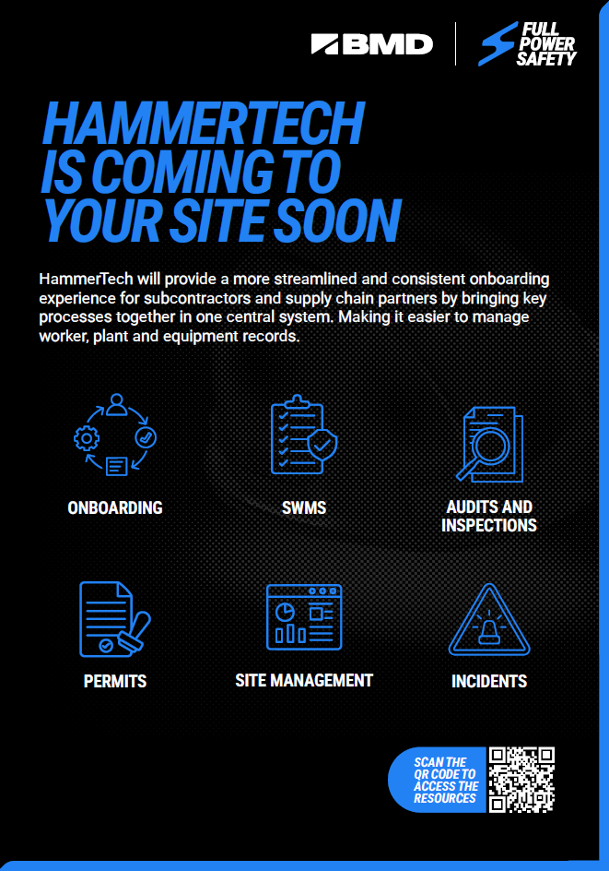
Person attending:
Name | Company | Signature

Facilitator: |  | Signature:

